Terraform Questions:
Objective 1- Understand Infrastructure vs Code concepts-IaC Best Practices:
- What best practice should the new employee follow to submit the new code?
  - Submit a merge/pull request of the proposed changes. Have a team member validate the changes and approve the request.
- Which of the following best describes the primary use of Infrastructure as Code (IaC)?
  - the ability to programmatically deploy and configure resources
- You work for a retail organization that has multiple peak seasons throughout the year. During those peak seasons, your applications need to be scaled up quickly to handle the increased demand. However, the deployment of application servers is manual and new servers are only deployed when problems are reported by users.
How can you reduce the effort required to deploy new resources, increase the speed of deployments, and reduce or eliminate the negative experiences of your customers?
  - Develop code that provisions new application servers programmatically. Use monitoring software to trigger a pipeline that deploys additional servers during periods of increased demand.
- Which of the following are advantages of using infrastructure as code (IaC) for your day-to-day operations?
  - enables self-service for developers and operators alike
  - API-driven workflows
  - provides the ability to version control the infrastructure and application architecture
  - ensures the security of applications provisioned on managed infrastructure
While Terraform can indeed help with the security of your applications, it won't guarantee it. You can combine Terraform with other tools, such as LaunchDarkly, SonarQube, DeepScan, and more using a CI/CD pipeline, but again, it doesn't guarantee the security of your application.
- What are the additional benefits of IaC? (select three)
  - code can easily be shared and reused
  - eliminates parallelism
  - creates a blueprint of your data center
  - allows infrastructure to be versioned
  - can always be used to deploy the latest features and services
Infrastructure is described using a high-level configuration syntax. This allows a blueprint of your datacenter to be versioned and treated as you would any other code. Additionally, infrastructure can be shared and re-used.
Infrastructure as Code almost always uses parallelism to deploy resources faster. And depending on the solution being used, it doesn't always have access to the latest features and services available on cloud platforms or other solutions.
- True or False? Terraform is designed to work only with public cloud platforms, and organizations that wish to use it for on-premises infrastructure (private cloud) should look for an alternative solution.
  - True
  - False
Terraform is designed to work with almost any infrastructure that provides an API. Terraform is very frequently used to provision infrastructure atop VMware infrastructure, along with traditional, physical security or infrastructure service solutions.
- Fill in the correct answers below:
Infrastructure as Code (IaC) makes infrastructure changes _______, ________, ________, and __________. (select four)
  - Idempotent (repeating the operation multiple time produces the same result)
  - consistent
  - predictable
  - highly-available
  - Repeatable
- There are an endless number of benefits to using Terraform within your organization. Which of the following are true statements regarding Terraform? (select three)
  - Terraform can manage dependencies within a single cloud, but not cross-cloud
  - Terraform can simplify both management and orchestration of deploying large-scale, multi-cloud infrastructure
  - A single Terraform configuration file can be used to manage multiple providers
  - Terraform is cloud-agnostic but requires a specific provider for the cloud platform
- Which of the following statements represents the most accurate statement about the Terraform language?
  - Terraform is a mutable, imperative, Infrastructure as Code provisioning language based on Hashicorp Configuration Language, or optionally YAML.
  - Terraform is an immutable, imperative, Infrastructure as Code configuration management language based on Hashicorp Configuration Language, or optionally JSON.
  - Terraform is a mutable, declarative, Infrastructure as Code configuration management language based on Hashicorp Configuration Language, or optionally JSON.
  - Terraform is an immutable, declarative, Infrastructure as Code provisioning language based on Hashicorp Configuration Language, or optionally JSON.
Declarative vs Imperative:
Terraform is declarative- Users define the desired state of their infrastructure without specifying the exact steps to achieve that state.
Mutable vs Immutable:
it is immutable. It focuses on defining the desired state of infrastructure and making changes to reach that state, rather than directly modifying existing infrastructure.

Objective 2 - Understand Terraform's purpose (vs other IaC)
- Aaron is new to Terraform and has a single configuration file ready for deployment. What can be true about this configuration file? (select three)
  - the state can be disabled when deploying to multiple clouds to prevent sensitive data from being shared across cloud platforms
  - the state file can be stored in Azure but provision applications in AWS
  - the configuration file can deploy both QA and Staging infrastructure for applications
  - Aaron's configuration file can deploy applications in both AWS and GCP
Terraform State
- Which of the following is true about the terraform.tfstate file used by Terraform?
  - the file can potentially contain sensitive values
  - the file includes information about each resource managed by Terraform
  - it always matches the infrastructure deployed with Terraform
  - it is recommended not to modify the file directly
- You have deployed your network architecture in AWS using Terraform. A colleague recently logged in to the AWS console and made a change manually and now you need to be sure your Terraform state reflects the new change.

What command should you run to update your Terraform state?
  - terraform apply -refresh-only
- terraform get -update is used to download and update modules that are referenced in your Terraform configuration files
- Which of the following is not a benefit of Terraform state?
- increases performance by reducing the requirement to query multiple resources at once
- determines the dependency order for deployed resources
- reduces the amount of outbound traffic by requiring that state is stored locally
- provides a one-to-one mapping of the configuration to real-world resources
- True or False? Rather than use a state file, Terraform can inspect cloud resources on every run to validate that the real-world resources match the desired state.
  - True
  - False
Terraform relies on state files to track the current state of infrastructure resources and compare it to the desired state declared in configuration files. Without a state file, Terraform would not be able to accurately determine the changes needed to align real-world resources with the desired state.

Terraform Providers
Objective 2 - Understand Terraform's purpose (vs other IaC)
- Which of the following are true about Terraform providers?
  - some providers are maintained by HashiCorp
  - all providers are automatically included when downloading Terraform
  - providers can be written and maintained by an outside organization, such as AWS, F5, or Microsoft
  - some providers are community-supported
  - they allow anybody to write a provider and publish it to the registry
- What are some of the benefits that Terraform providers offer to users?
  - enforces security compliance across multiple cloud providers
  - abstracts the target platform's API from the end-user
  - enables the deployment of resources to multiple platforms, such as public cloud, private cloud, or other SaaS, PaaS, or IaaS services
  - enables a plugin architecture that allows Terraform to be extensible without having to update Terraform core
Terraform enables its users to interact with a platform's API without requiring the end-user to understand individual APIs for the targeted platform. This allows a user to easily provision and manage resources across many different platforms without having to understand the API for each individual backend. This benefit makes users more efficient and reduces the administrative burden for understanding and troubleshooting each one.

Terraform can support any platform that has an API, including public, private, and other offerings on the market today. If it has an API, a provider can be written to allow Terraform to manage it.

Objective 3 - Understand Terraform Basics
- When using Terraform, where can you install providers from?
  - The provider’s source code
  - plugins directory
  - Terraform registry
  - Terraform plugin cache
  - official HashiCorp releases site
- True or False? When developing Terraform code, you must include a provider block for each unique provider so Terraform knows which ones you want to download and use.
  - False
  - True
a provider block may be omitted if its contents would otherwise be empty. Terraform assumes an empty default configuration for any provider that is not explicitly configured.
- You need to use multiple resources from different providers in Terraform to accomplish a task. Which of the following can be used to configure the settings for each of the providers?
  - 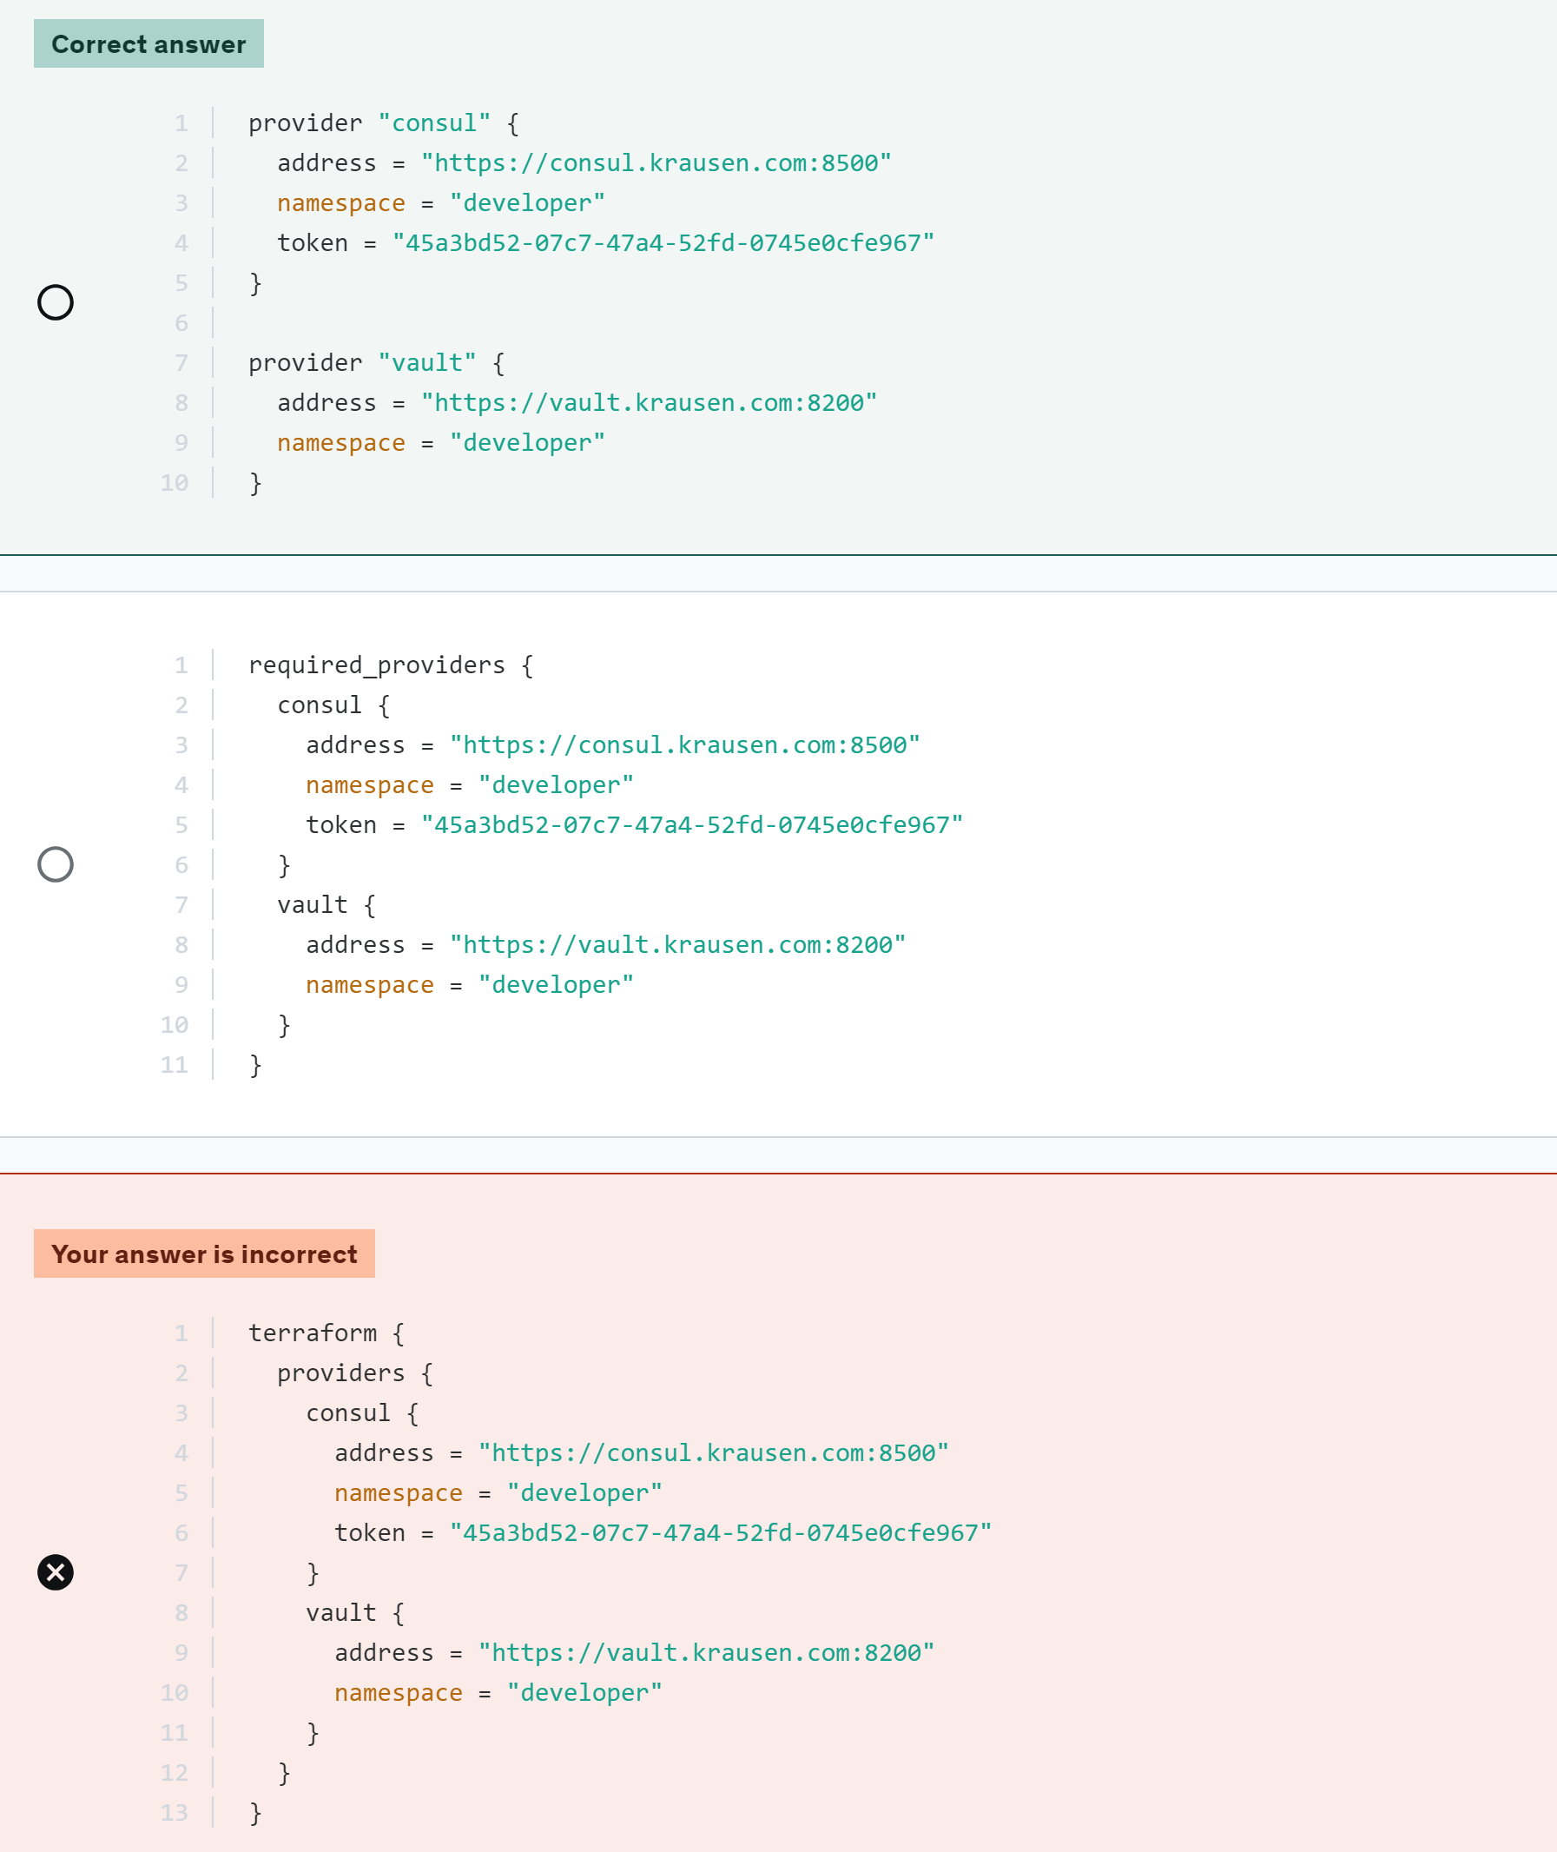
  - When declaring terraform provider
  - Provider requirement :
in terraform.tf file
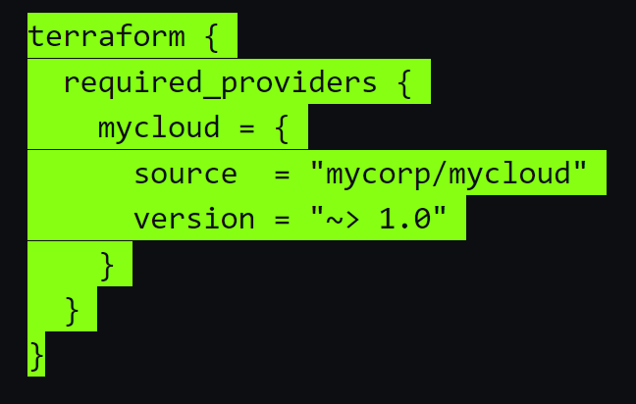
  - Provider configuration settings :
in provider.tf or main.tf file
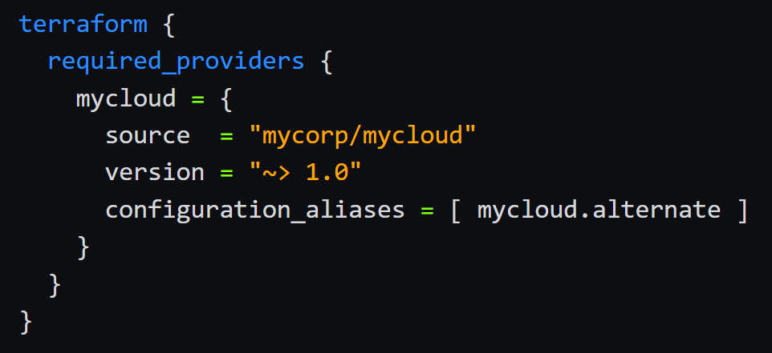
- You have recently cloned a repo containing Terraform that you want to test in your environment. Once you customize the configuration, you run a terraform apply but it immediately fails. Why would the apply fail?
  - Terraform needs to initialize the directory and download the required plugins
- You are using Terraform to manage resources in Azure. Due to unique requirements, you need to specify the version of the Azure provider so it remains the same until newer versions are thoroughly tested.
What block would properly configure Terraform to ensure it always installs the same Azure provider version?

- 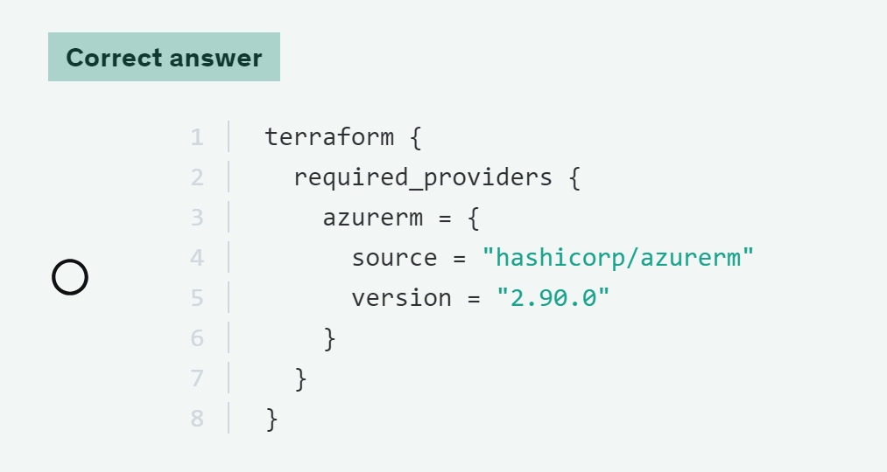
- A provider alias is used for what purpose in a Terraform configuration file?
  - to signify what resources should be deployed to a certain cloud provider
  - to use as shorthand for resources to be deployed with the referenced provider
  - alias isn't used with providers, they are used with provisioners
  - using the same provider with different configurations for different resources
- it's common that Terraform needs credentials to access the API for the underlying platform, such as VMware, AWS, or Google Cloud. While there are many ways to accomplish this, what are three options that you can provide these credentials? (select three)
  - integrated services, such as AWS IAM or Azure Managed Service Identity
Integrated services like AWS IAM or Azure Managed Service Identity can be utilized to provide credentials to Terraform. These services offer secure and managed ways to access the API of the underlying platform without exposing sensitive information in the Terraform configuration.
  - use environment variables
Using environment variables is another common method to provide credentials to Terraform. By setting environment variables, Terraform can access the necessary credentials without exposing them directly in the configuration files.
  - using the resources block in your configuration
  - directly in the provider block by hardcoding or using a variable
Storing credentials directly in the provider block is a common way to provide access to the underlying platform's API. This can be done by hardcoding the credentials or using Terraform variables to keep them secure and manageable.
- Using the Terraform code below, where will the resource be provisioned?
provider "aws" {
region = "us-east-1"
}

provider "aws" {
alias = "west"
region = "us-west-2"
}

provider "aws" {
alias = "eu"
region = "eu-west-2"
}

resource "aws_instance" "vault" {
ami = data.aws_ami.amzlinux2.id
instance_type = "t3.micro"
key_name = "krausen_key"
vpc_security_group_ids = var.vault_sg
subnet_id = var.vault_subnet
user_data = file("vault.sh")

tags = {
Name = "vault"
}
}

  - us-east-1
  - us-west-2
  - us-west-1
Resource does not declares any provider_name.alias
Selecting Alternate Provider Configurations

To use an alternate provider configuration for a resource or data source, set its provider meta-argument to a <PROVIDER NAME>.<ALIAS> reference:

resource "aws_instance" "foo" {
provider = aws.west

# ...
}

To select alternate provider configurations for a child module, use its providers meta-argument to specify which provider configurations should be mapped to which local provider names inside the module:

module "aws_vpc" {
source = "./aws_vpc"
providers = {
aws = aws.west
}
}

- Scenario: You are deploying a new application and want to deploy it to multiple AWS regions within the same configuration file. Which of the following features will allow you to configure this?
  - using the default provider along with a single defined provider
  - a provider with multiple versions defined
  - one provider block that defines multiple regions
  - multiple provider blocks using an alias
- What feature of Terraform provides an abstraction above the upstream API and is responsible for understanding API interactions and exposing resources?
  - Terraform configuration file
  - Terraform backend
  - Terraform provider
  - Terraform provisioner
Terraform relies on plugins called "providers" to interact with remote systems.
Misc:
- True or False? A main.tf file is always required when using Terraform?
  - False
  - True
Although main.tf is the standard name, it's not necessarily required. Terraform will look for any file with a .tf or .tf.json extension when running terraform commands.
- Based on the Terraform code below, what block type is used to define the VPC?

vpc_id = aws_vpc.main.id
...
  - resource block
  - locals block
  - provider block
  - data block

Objective 3 - Understand Terraform Basics
Terraform fmt
- True or False? Running a terraform fmt will modify Terraform configuration files in the current working directory and all subdirectories.
  - False
  - True
terraform fmt will format the current working directory.
to format sub dirs use terraform fmt -recursive
- What command could you run to easily rewrite your Terraform to follow the HCL style in both the current directory and all sub-directories?
  - terraform fmt -check
  - terraform fmt -recursive
  - terraform fmt -list=false
  - terraform fmt -diff
Miscellaneous
- True or False? Using the latest versions of Terraform, terraform init cannot automatically download community providers.
  - True
  - False
- Provider dependencies are created in several different ways. Select the valid provider dependencies from the following list: (select three)
  - Use of any resource block or data block in the configuration, belonging to a particular provider
When any resource block or data block is used in the configuration, it indicates a dependency on the provider associated with those blocks, as they are responsible for managing those specific resources.
  - Existence of any provider plugins found locally in the working directory.
The existence of provider plugins locally in the working directory does not establish a direct dependency on the provider for the resources being managed. Terraform relies on the configuration and state to determine provider dependencies.
  - Existence of any resource instance belonging to a particular provider in the current state.
The existence of any resource instance belonging to a particular provider in the current state signifies a dependency on that provider, as Terraform needs access to the provider to manage the state of those resources.
  - Explicit use of a provider block in configuration, optionally including a version constraint.
The explicit use of a provider block in the configuration, along with an optional version constraint, establishes a direct dependency on that specific provider for the resources being managed.
The existence of a provider plugin found locally in the working directory does not itself create a provider dependency. The plugin can exist without any reference to it in the Terraform configuration.
- A user runs terraform init on their RHEL-based server, and per the output, two provider plugins are downloaded:
Where are these plugins downloaded and stored on the server?
  - The .terraform/providers directory in the current working directory
  - /etc/terraform/plugins
  - The .terraform.d directory in the current working directory
  - The .terraform.plugins directory in the current working directory
- While Terraform is generally written using the HashiCorp Configuration Language (HCL). What other syntax can Terraform be expressed in?
  - JSON
  - YAML
  - XML
  - TypeSCript
- When multiple arguments with single-line values appear on consecutive lines at the same nesting level, HashiCorp recommends that you:
  - align the equals signs
- Terraform is distributed as a single binary and available for many different platforms. Select all operating systems that Terraform is available for. (select five)
  - AIX
  - Windows
  - MacOS
  - FreeBSD
  - Linux
  - Solaris
- When using constraint expressions to signify a version of a provider, which of the following are valid provider versions that satisfy the expression found in the following code snippet: (select two)
terraform {
required_providers {
aws = {
source = "hashicorp/aws"
version ~> "5.36.0"
}
}
}
- Version 5.37.0
- 5.36.9
- 5.36.3
- 5.3.1
~>: Allows only the rightmost version component to increment. This format is referred to as the pessimistic constraint operator.
- You are writing Terraform to deploy resources, and have included provider blocks as shown below:
provider "aws" {
region = "us-east-1"
}

provider "aws" {
region = "us-west-1"
}

When you validate the Terraform configuration, you get the following error:

Error: Duplicate provider configuration

on main.tf line 5:
5: provider "aws" {

A default provider configuration for "aws" was already given at
main.tf:1,1-15. If multiple configurations are required, set the xxxx
argument for alternative configurations.

What additional parameter is required to use multiple provider blocks of the same type, but with distinct configurations, such as cloud regions, namespaces, or other desired settings?
- Label
- Version
- Alias
- Multi
- Environment variables can be used to set the value of input variables. The environment variables must be in the format "____"_<variablename>.
Select the correct prefix string from the following list.
  - TF_ENV_VAR
  - TF_ENV
  - TF_VAR
  - TF_VAR_VALUE
- Why might a user opt to include the following snippet in their configuration file?
terraform {
required_version = ">= 1.7.5"
}
- this ensures that all Terraform providers are above a certain version to match the application being deployed
  - The user wants to specify the minimum version of Terraform that is required to run the configuration
- The user wants to ensure that the application being deployed is a minimum version of 1.7.5
- versions before Terraform 1.7.5 were not approved by HashiCorp to be used in production
- When writing Terraform code, how many spaces between each nesting level does HashiCorp recommend that you use?
  - 5
  - 4
  - 1
  - 2

Objective 4 – Use terraform outside core workflow
- You are using Terraform OSS and need to spin up a copy of your GCP environment in a second region to test some new features. You create a new workspace. Which of the following is true about this new workspace? (select four)
  - it uses a different Terraform backend
  - it has its own state file
  - changes to this workspace won't impact other workspaces
  - you can use a different variables file for this workspace if needed
  - it uses the same Terraform code in the current directory
- After running terraform apply, you notice some odd behavior and need to investigate. Which of the following environment variables will configure Terraform to write more detailed logs to assist with troubleshooting?
  - TF_LOG_CONFIG=WARN
  - TF_LOGS=ERROR
  - TF_LOG=TRACE
  - LOG_CONFIG=INFO
You can set TF_LOG to one of the log levels TRACE, DEBUG, INFO, WARN or ERROR to change the verbosity of the logs. TRACE is the most verbose and it is the default if TF_LOG is set to something other than a log level name.
- Which of the following statements are true about using terraform import? (select three)
  - the terraform import command will automatically update the referenced Terraform resource block after the resource has been imported to ensure consistency
terraform import will NOT create the resource block for you. You must create the resource block in your Terraform configuration before using the import command
  - you must update your Terraform configuration for the imported resource before attempting to import the resource
  - using terraform import will bring the imported resource under Terraform management and add the new resource to the state file
  - the resource address (example: aws_instance.web) and resource ID (example: i-abdcef12345) must be provided when importing a resource
- Which of the following Terraform CLI commands are valid? (select five)
  - $ terraform initialize
  - $ terraform show
  - $ terraform workspace select
  - $ terraform login
  - $ terraform fmt
  - terraform apply -refresh-only
  - $ terraform delete
Terraform state
- Pam just finished up a new Terraform configuration file and has successfully deployed the configuration on Azure using Terraform open-source. After confirming the configuration on Azure, Pam changes to a new workspace and then heads to lunch. When she arrives back at her desk, Pam decides to destroy the resources to save on cost. When Pam executes a terraform destroy, the output indicates there are no resources to delete.
Why can't Pam delete the newly created resources in Azure?
- an Azure administrator manually deleted the resources
- there is no Terraform state in the current workspace she is working in
- the Terraform state was deleted when she created the new workspace
- Terraform reached the maximum timeout while Pam was away from lunch, therefore the resources were automatically destroyed

- Steve is a developer who is deploying resources to AWS using Terraform. Steve needs to gather detailed information about an EC2 instance that he deployed earlier in the day. What command can Steve use to view this detailed information?
  - terraform state show aws_instance.frontend
will show you a lot of details on the resource
  - terraform state rm aws_instance.frontend
would remove the resource from state. This would not destroy the resource on the public cloud, but it would tell Terraform to stop managing it.
  - terraform state list
will just show you a list of the resources being managed by Terraform
  - terraform state pull
will download the state from its current location, upgrade the local copy to the latest state file version that is compatible with locally-installed Terraform, and output the raw format to stdout
- You need Terraform to destroy and recreate a single database server that was deployed with a bunch of other resources. You don't want to modify the Terraform code. What command can be used to accomplish this task?
  - terraform state rm aws_instance.database
  - terraform apply -replace="aws_instance.database"
  - terraform plan -destroy="aws_instance.database"
  - terraform state show aws_instance.database
- Jeff received a request to remove a specific VMware virtual machine from Terraform as the application team no longer needs it. Jeff opens his terminal and issues the command:

$ terraform state rm vsphere_virtual_machine.app1

Removed vsphere_virtual_machine.app1
Successfully removed 1 resource instance(s).

The next time that Jeff runs a terraform apply, the resource is not marked to be deleted. In fact, Terraform is stating that it is creating another identical resource.
What would explain the above behaviour?
- the state file was not saved before the terraform apply was executed, therefore Terraform sees that the resource is still in the state file
- Jeff removed the resource from the state file, and not the configuration file. Therefore, Terraform is no longer aware of the virtual machine and assumes Jeff wants to create a new one since the virtual machine is still in the Terraform configuration file

- after running the terraform rm command, Jeff needs to run a Terraform plan first to tell Terraform of the updated configuration. A plan will instruct Terraform that the resource should be deleted upon the next terraform apply
- the resource was manually deleted within the VMware infrastructure and needs to be recreated
terraform workspace
- A user has created three workspaces using the command line - prod, dev, and test. The user wants to create a fourth workspace named stage.
Which command will the user execute to accomplish this task?
- terraform workspace create stage
- terraform workspace new stage
- terraform workspace -new stage
- terraform workspace -create stage
- A user creates three workspaces from the command line: prod, dev, and test. Which of the following commands will the user run to switch to the dev workspace?
  - terraform workspace dev
  - terraform workspace -switch dev
  - terraform workspace select dev
  - terraform workspace switch dev
- What tasks can the terraform state command be used for in Terraform?
  - there is no such command
  - create a new state file
  - modify the current state, such as removing items
  - refresh the existing state
- Emma is a Terraform expert, and she has automated all the things with Terraform. A virtual machine was provisioned during a recent deployment, but a local script did not work correctly. As a result, the virtual machine needs to be destroyed and recreated.
how can Emma quickly have Terraform recreate the one resource without having to destroy everything that was created?
  - use terraform state rm aws_instance.web to remove the resource from the state file, which will cause Terraform to recreate the instance again
  - use terraform apply -replace=aws_instance.web to mark the virtual machine for replacement
  - use terraform refresh to refresh the state and make Terraform aware of the error
  - use terraform import to import the error so Terraform is aware of the problem
The command `terraform state rm aws_instance.web` removes the specified resource from the state file, prompting Terraform to recreate the instance during the next apply. This method is not recommended in this scenario as it removes the resource entirely from the state.
Using `terraform apply -replace=aws_instance.web` allows Emma to mark the specific virtual machine resource for replacement without affecting other resources that were created. This command is useful for quickly recreating a single resource.
Objective 5- Interact with terraform modules
- True or False? Official Terraform providers and modules are owned and maintained by HashiCorp.
  - True
  - False
If a module or provider is marked as official, it is owned and maintained by HashiCorp themselves
- You have a module named prod_subnet that outputs the subnet_id of the subnet created by the module. How would you reference the subnet ID when using it for an input of another module?
  - subnet = module.outputs.prod_subnet.subnet_id
  - subnet = prod_subnet.subnet_id
  - subnet = prod_subnet.outputs.subnet_id
  - subnet = module.prod_subnet.subnet_id
Using interpolation, you can reference the output of an exported value by using the following syntax: module.<module name>.<output name>
Don't forget that before you can reference data/values from a module, the module has to have an output declared that references the desired value(s).

- You have declared a variable named db_connection_string inside of the app module. However, when you run a terraform apply, you get the following error message:

Error: Reference to undeclared input variable
on main.tf line 35:
4: db_path = var.db_connection_string
An input variable with the name "db_connection_string" has not been declared. This variable can be declared with a variable "db_connection_string" {} block.
Why would you receive such an error?
  - an output block was not created in the module, and therefore the variable cannot be referenced
While an output block would allow you to get information from within the module, creating an output block still wouldn't allow you to reference the variable directly using the var.<name> nomenclature.
  - the variable should be referenced as var.module.app.db_connection_string
  - input variables are not referenced using the var prefix
  - since the variable was declared within the module, it cannot be referenced outside of the module
When using modules, it's common practice to declare variables outside of the module and pass the value(s) to the child module when it is called by the parent/root module. However, it's perfectly acceptable to declare a variable inside of a module if you needed. Any variables declared inside of a module are only directly referencable within that module. You can't directly reference that variable outside of the module. You can, however, create an output in the module to export any values that might be needed outside of the module.
- Which of the following is true about working with modules?
  - a module can only contain a single resource to be deployed or managed
  - a single module can be called many times in a single configuration file
  - every module that is called from a parent module must output values
  - modules must be published to the Terraform registry before they can be used
correct answer. Modules can be called one or more times by a parent module. The whole point of using a module is to be able to call it one or many times to create resources without having to rewrite the same code over and over.
WRONG ANSWERS:
Where do modules live? While modules can be published to the Terraform registry, they don't have to be. They can be simply stored locally on your machine or in a private code repository. Publishing them to the public registry, or using a private registry, is completely optional.
Module outputs: While modules are often more valuable when they output values, they don't necessarily have to output values. They can be used to simply manage resources. If you do need values from the module, that's when you'd create outputs. Those outputs can be used just for informational purposes or they can be used as inputs for other modules. For example, you might create a subnet in a public cloud in one module and need to output the subnet ID so you can use it as an input on a second module to deploy application workloads.
Resources in Modules: Modules can be used to deploy and manage one or more resources within the module. For example, you might need to deploy multiple resources needs for a specific application or requirements.
- When initializing Terraform, you notice that Terraform's CLI output states it is downloading the modules referenced in your code. Where does Terraform cache these modules?
  - in the .terraform/modules subdirectory in the current working directory
  - in the /tmp directory on the machine executing Terraform
  - in a /modules directory in the current working directory
  - in the /downloads directory for the user running the terraform init
- Given the following snippet of code, what does servers = 4 reference?
module "servers" {
source = "./modules/aws-servers"

servers = 4
}
  - servers is not a valid configuration for a module
  - the output variable of the module
  - the number of times the module will be executed
  - the value of an input variable
- Teddy is using Terraform to deploy infrastructure using modules. Where is the module below stored?

module "monitoring_tools" {
source = "./modules/monitoring_tools"

cluster_hostname = module.k8s_cluster.hostname
}
  - in a public GitLab repository
  - locally on the instance running Terraform
  - on the Terraform public registry
  - a private registry in Terraform Cloud (free)
- Margaret is calling a child module to deploy infrastructure for her organization. Just as a good architect does (and suggested by HashiCorp), she specifies the module version she wants to use even though there are newer versions available. During a terrafom init, Terraform downloads v0.0.5 just as expected.
What would happen if Margaret removed the version parameter in the module block and ran a terraform init again?

module "consul" {
source = "hashicorp/consul/aws"
version = "0.0.5"

servers = 3
}
  - Terraform would skip the module
  - Terraform would use the existing module already downloaded
  - Terraform would return an error, as the version parameter is required
  - Terraform would download the latest version of the module
Terraform consults version constraints to determine whether it has acceptable versions of itself, any required provider plugins, and any required modules. For plugins and modules, it will use the newest installed version that meets the applicable constraints.
When second time there is no version constraint mentioned it uses the already downloaded version
- Which of the following are the benefits of using modules in Terraform? (select three)
  - supports versioning to maintain compatibility
  - enables code reuse
  - supports modules stored locally or remotely
  - allows modules to be stored anywhere accessible by Terraform
The module installer supports installation from a number of different source types.
- Local paths
- Terraform Registry
- GitHub
- Bitbucket
- Generic Git, Mercurial repositories
- HTTP URLs
- S3 buckets
- GCS buckets
- Modules in Package Sub-directories
- Rigby is implementing Terraform and was given a configuration that includes the snippet below. Where is this particular module stored?

module "consul" {
source = "hashicorp/consul/aws"
version = "0.1.0"
}
  - public Terraform registry
  - a private registry supported by your organization
  - locally but a directory back from the current directory
  - locally in the hashicorp/consul/aws directory
Modules on the public Terraform Registry can be referenced using a registry source address of the form <NAMESPACE>/<NAME>/<PROVIDER>, with each module's information page on the registry site including the exact address to use.
- Sara has her entire application automated using Terraform, but she needs to start automating more infrastructure components, such as creating a new subnet, DNS record, and load balancer. Sara wants to create these new resources using modules so she easily reuse the code. However, Sara is having problems getting the subnet_id from the subnet module to pass to the load balancer module.
what could solve the problem?
  - add an output block to the subnet module and retrieve the value using module.subnet.subnet_id for the load balancer module
  - move the subnet and load balancer resource into the main configuration file so they can easily be referenced
  - references to resources that are created within a module cannot be used within other modules
  - publish the module to a Terraform registry first
- You are performing a code review of a colleague's Terraform code and see the following code. Where is this module stored?
module "vault-aws-tgw" {
source = "terraform-vault-aws-tgw/hcp"
  - in a local file under a directory named terraform/vault-aws-tgw/hcp
  - in a Terraform Cloud private registry
  - a local code repository on your network
  - terraform public registry
- What do the declarations, such as name, cidr, and azs, in the following Terraform code represent and what purpose do they serve?
module "vpc" {
source = "terraform-aws-modules/vpc/aws"
version = "5.7.0"

name = var.vpc_name
cidr = var.vpc_cidr

azs = var.vpc_azs
private_subnets = var.vpc_private_subnets
public_subnets = var.vpc_public_subnets

enable_nat_gateway = var.vpc_enable_nat_gateway

tags = var.vpc_tags
}
  - the value of these variables will be obtained from values created within the child module
  - these are variables that are passed into the child module likely used for resource creation
  - these are where the variable declarations are created so Terraform is aware of these variables within the calling module
  - these are the outputs that the child module will return
- When you add a new module to a configuration, Terraform must download it before it can be used. What two commands can be used to download and update modules? (select two)
  - Terraform get
When you add a new module to a configuration, Terraform must download it before it can be used. What two commands can be used to download and update modules? (select two)
  - Terraform refresh
  - Terraform init
  - Terraform plan
- Anyone can publish and share modules on the Terraform Public Registry, and meeting the requirements for publishing a module is extremely easy.
What are some of the requirements that must be met in order to publish a module on the Terraform Public Registry? (select three)
  - Module repositories must use this three-part name format, terraform-<PROVIDER>-<NAME>.
  - The registry uses tags to identify module versions. Release tag names must be for the format x.y.z, and can optionally be prefixed with a v .
  - The module must be PCI/HIPPA compliant.
  - The module must be on GitHub and must be a public repo.
Objective 6- Use the core terraform workflow
- Thomas has recently developed a new Terraform configuration in a new working directory and is very cost-conscious. After running a terraform init, how can Thomas perform a dry run to ensure Terraform will create the right resources without deploying real-world resources?
  - run terraform output
  - Your answer is correct
  - run terraform plan -out=thomas
  - run terraform show
  - run terraform apply -refresh-only

- Which of the following tasks does terraform init perform? (select three)
  - updates your state file based on any new changes
  - downloads required providers used in your configuration file
  - caches the source code locally for referenced modules
  - creates a sample Terraform configuration file in the working directory
  - prepares the working directory for use with Terraform
- What CLI commands will completely tear down and delete all resources that Terraform is currently managing? (select two)
  - terraform apply -destroy
  - terraform destroy
  - terraform apply -delete
  - terraform plan -destroy
- You are working on updating your infrastructure managed by Terraform. Before lunch, you update your configuration file and run a terraform plan to validate the changes. While you are away, a colleague manually updates a tag on a managed resource directly in the console (UI).
What will happen when you run a terraform apply?
  - Terraform will recognize the manual change and return an error since the Terraform state no longer matches the real-world infrastructure.
  - Before applying the new configuration, Terraform will refresh the state and recognize the manual change. It will update the resource based on the desired state as configured in the Terraform configuration. The manual change will no longer exist.
  - Terraform will update the manually changed resource back to the original configuration. It will then apply the new changes defined in the updated configuration file.
  - Terraform will destroy the manually-changed resource and recreate it to ensure the infrastructure matches the desired state.
Since a resource was manually changed, it means that Terraform state is no longer accurate. However, before a terraform plan or terraform apply is executed, Terraform refreshes its state to ensure it knows the status of all its managed resources. During this process, Terraform would recognize the change, update state, and compare that to the new configuration file. Assuming the change defined in the configuration is identical to the manual change, Terraform would simply apply any changes (if any), update the state file, and complete the terraform apply.
- True or False? A terraform plan is a required step before running a terraform apply?
  - True
  - False
- Philip works at a payment processing company and manages the organization's VMware environment. He recently provisioned a new cluster for a production environment. To ensure everything is working as expected, Philip has been using Terraform and the VMware vSphere client to create and destroy new virtual machines. Currently, there are three virtual machines running on the new cluster, so Philip runs terraform destroy to remove the remaining virtual machines from the cluster. However, Terraform only removes two of the virtual machines, leaving one virtual machine still running.

Why would Terraform only remove two of the three virtual machines?
  - the remaining virtual machine was not created by Terraform, therefore Terraform is not aware of the virtual machine and cannot destroy it
  - Terraform can only destroy a maximum of 2 resources per terraform destroy execution
  - the virtual machine was marked with vSphere tags to prevent it from being destroyed
  - the vSphere provider credentials are invalid, and therefore Terraform cannot reach the third virtual machine
- What function does the terraform init -upgrade command perform?
  - upgrades all of the referenced modules and providers to the latest version of Terraform
  - upgrades the backend to the latest supported version
  - update all previously installed plugins and modules to the newest version that complies with the configuration’s version constraints
  - upgrades the Terraform configuration file(s) to use the referenced Terraform version
- You have created a new workspace for a project and added all of your Terraform configuration files in the new directory. Before you execute a terraform plan, you want to validate the configuration using the terraform validate command. However, Terraform returns the error:

$ terraform validate
Error: Could not load plugin

What would cause this error when trying to validate the configuration?
  - the credentials for the provider are invalid
  - the directory does not contain valid Terraform configuration files
  - the directory was not initialized
  - the configuration is invalid
- When running the terraform validate command, which issue will be brought to your attention?
  - there is no existing state file for the configuration
  - there is configuration drift within the managed infrastructure
  - a variable is being used in a resource block but has not been declared
  - parameters inside of a resource block are not lined up with space
- What happens when you apply a Terraform configuration using terraform apply? (select two)
  - Terraform downloads any required plugins
  - Terraform updates the state file with configuration changes made during the execution
  - Terraform recreates all the infrastructure defined in the configuration file
  - Terraform formats your configuration to the standard canonical format and style
  - Terraform makes infrastructure changes defined in your configuration.
- Henry has been working on automating his Azure infrastructure for a new application using Terraform. His application runs successfully, but he has added a new resource to create a DNS record using the new Infoblox provider. He has added the new resource but gets an error when he runs a terraform plan.
What should Henry do first before running a plan and apply?
  - Henry should run a terraform plan -refresh=true to update the state for the new DNS resource
  - since a new provider has been introduced, terraform init needs to be run to download the Infoblox plugin
  - the Azure plugin doesn't support Infoblox directly, so Henry needs to put the DNS resource in another configuration file
  - you can't mix resources from different providers within the same configuration file, so Henry should create a module for the DNS resource and reference it from the main configuration
- True or False? By default, the terraform destroy command will prompt the user for confirmation before proceeding.
  - True
  - False
- Oscar is modifying his Terraform configuration file but isn't 100% sure it's correct. He is afraid that changes made could negatively affect production workloads.
how can Oscar validate the changes that will be made without impacting existing workloads?
  - run a terraform validate to ensure the changes won't impact the production workloads
  - run terraform apply -lock=false when executing the the changes made to the configuration
  - run a terraform plan and validate the changes that will be made
  - run terraform refresh to compare his existing configuration file against the current one
- In order to reduce the time it takes to provision resources, Terraform uses parallelism. By default, how many resources will Terraform provision concurrently during a terraform apply?
  - 10
  - 20
  - 5
  - 50
Objective 7- Implement and maintain state
- True or False? In most cases, you can move Terraform state between supported backends at any time, even after running your first terraform apply.
  - True
  - False
You can change both the configuration itself as well as the type of backend (for example from "consul" to "s3"). However, there may be limitations when migrating certain backends to others. For example, you may not be able to move from TFC to a local backend as it might not be supported.
Terraform will automatically detect any changes in your configuration and request a reinitialization. As part of the reinitialization process, Terraform will ask if you'd like to migrate your existing state to the new configuration. This allows you to easily switch from one backend to another.

- Your co-worker has decided to migrate Terraform state to a remote backend. They configure Terraform with the backend configuration, including the type, location, and credentials. However, you want to secure this configuration better.
Rather than storing them in plaintext, where should you store the credentials for the remote backend? (select two)
  - environment variables
  - use a variable
  - credentials file
  - on the remote system
- Your team is using Terraform, and multiple team members need to be able to manage the infrastructure. You need to support state locking to reduce the chance of corrupting the state file. What backends can you use to meet these requirements? (select three)
  - local backend
  - kubernetes backend
  - consul backend
  - s3 backend (with DynamoDB)
Not all Terraform backends are created equal. Some backends act like plain "remote disks" for state files; others support locking the state while operations are being performed, which helps prevent conflicts and inconsistencies.
Kubernetes, Consul, and S3 backends all support state locking. S3 supports state locking with the help of DynamoDB.
While the local backend does support locking via system APIs, you can't use the local backend to share the state across your team.

- You are worried about unauthorized access to the Terraform state file since it might contain sensitive information. What are some ways you can protect the state file? (select two)

  - replicate the state file to an encrypted storage device
  - enable native encryption in Terraform as configured in the terraform block
  - store in a remote backend that encrypts state at rest
  - use the S3 backend using the encrypt option to ensure state is encrypted
Terraform Cloud always encrypts state at rest and protects it with TLS in transit. Terraform Cloud also knows the identity of the user requesting state and maintains a history of state changes. This can be used to control access and track activity. Terraform Enterprise also supports detailed audit logging.
The S3 backend supports encryption at rest when the encrypt option is enabled. IAM policies and logging can be used to identify any invalid access. Requests for the state go over a TLS connection.
- By default, Terraform OSS stores its state file in what type of backend?
  - remote backend
  - local backend
  - shared backend
  - encrypted backend
- Which of the following code snippets will properly configure a Terraform backend?
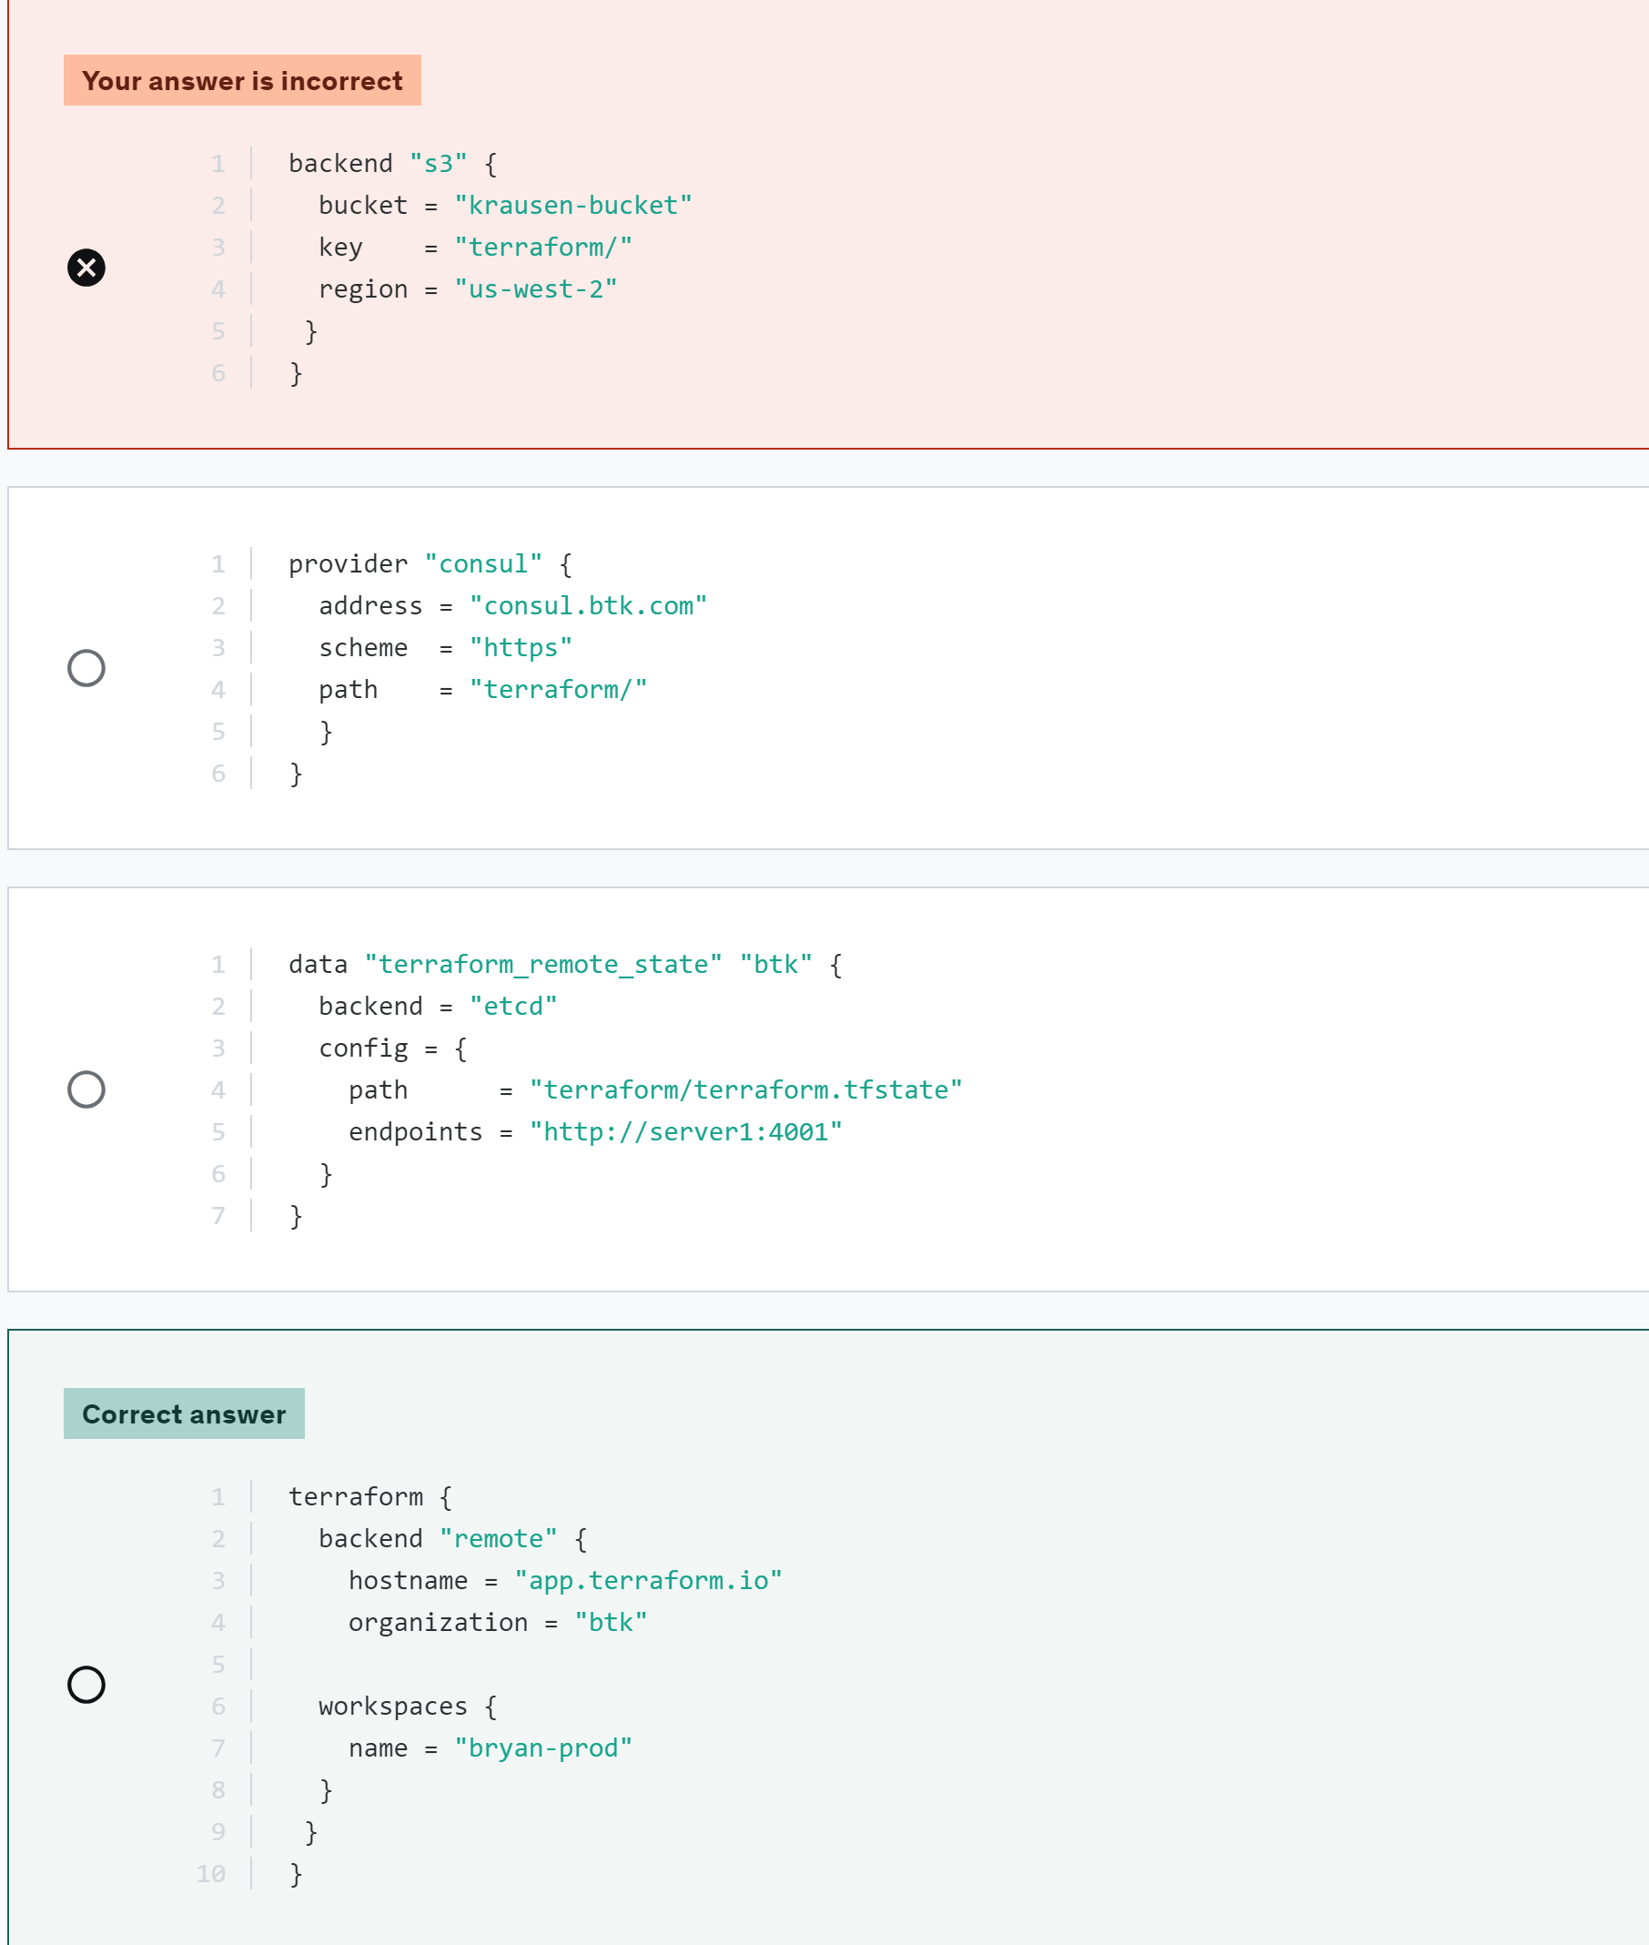
- After using Terraform locally to deploy cloud resources, you have decided to move your state file to an Amazon S3 remote backend. You configure Terraform with the proper configuration as shown below. What command should be run in order to complete the state migration while copying the existing state to the new backend?
  - terraform init -migrate-state
  - terraform apply -refresh-only
  - terraform plan -replace
  - terraform state show
- If supported by your backend, Terraform will lock your state for all operations that could write state. What purpose does this serve?
  - Prevents others from committing Terraform code that could override your updates.
  - Ensures the state file cannot be moved after the initial terraform apply
  - This prevents others from acquiring the lock and potentially corrupting your state.
  - Locks colleagues from making manual changes to the managed infrastructure
Even with state locking, somebody could make manual changes to your infrastructure using the API, CLI, or console if they wanted to. State locking doesn't prevent this.
- Which common action does not cause Terraform to refresh its state?
  - terraform destroy
  - terraform plan
  - terraform apply
  - terraform state list
- Which of the following commands can be used to detect configuration drift?
  - terraform init
  - terraform get
  - terraform apply -refresh-only
  - terraform fmt
- You have a Terraform configuration file defining resources to deploy on VMware, yet there is no related state file. You have successfully run terraform init already. What happens when you run a terraform apply?
  - Since there is no state file associated with this configuration file, the defined resources will be not created on the VMware infrastructure.
  - All existing infrastructure on VMware will be deleted, and the resources defined in the configuration file will be created.
  - Terraform will produce an error since there is no state file
  - Terraform will scan the VMware infrastructure, create a new state file, and deploy the new resources as defined in the configuration file
- What happens if multiple users attempt to run a terraform apply simultaneously when using a remote backend? (select two)
  - if the backend does not support locking, the state file could become corrupted
  - both users will get an error
  - if the backend supports locking, the first terraform apply will lock the file for changes, preventing the second user from running the apply
  - the Terraform apply will work for both users
- There are multiple ways to provide sensitive values when using Terraform. However, sensitive information provided in your configuration can be written to the state file, which is not desirable. Which method below will not result in sensitive information being written to the state file?
  - using a declared variable
  - using a tfvars file
  - retrieving the credentials from a data source, such as HashiCorp Vault
  - none of the above
When using sensitive values in your Terraform configuration, all of the configurations mentioned above will result in the sensitive value being written to the state file.
- You have a Terraform configuration file with no defined resources. However, there is a related state file for resources that were created on AWS. What happens when you run a terraform apply?
  - Terraform will not perform any operations.
  - Terraform will scan the AWS infrastructure and create a new configuration file based on the state file.
  - Terraform will destroy all of the resources
  - Terraform will produce an error since there are no resources defined
- Ralphie has executed a terraform apply using a complex Terraform configuration file. However, a few resources failed to deploy due to incorrect variables. After the error is discovered, what happens to the resources that were successfully provisioned?
  - the resources that were successfully provisioned will remain as deployed
  - resources successfully deployed are marked for replacement
  - Terraform deletes the resources on the next run
  - Terraform rolls back the configuration due to the error, therefore the resources are automatically destroyed
During a terraform apply, any resources that are successfully provisioned are maintained as deployed.
On the other hand, resources that failed during the provisioning process, such as a provisioned, will be tainted to be recreated during the next run.
- True or False? The terraform plan -refresh-only command is used to create a plan whose goal is only to update the Terraform state to match any changes made to remote objects outside of Terraform.
  - True
  - False
- Freddy and his co-worker Jason are deploying resources in GCP using Terraform for their team. After resources have been deployed, they must destroy the cloud-based resources to save on costs. However, two other team members, Michael and Chucky, are using a Cloud SQL instance for testing and request to keep it running.
How can Freddy and Jason destroy all other resources without negatively impacting
the database?
  - delete the entire state file using the terraform state rm command and manually delete the other resources in GCP
  - run a terraform state rm command to remove the Cloud SQL instance from Terraform management before running the terraform destroy command
  - run a terraform destroy, modify the configuration file to include only the Cloud SQL resource, and then run a terraform apply
  - take a snapshot of the database, run a terraform destroy, and then recreate the database in the GCP console by restoring the snapshot
- Where does Terraform Community (Free) store the local state for workspaces?
  - directory called terraform.workspaces.tfstate
  - a file called terraform.tfstate.backup
  - a file called terraform.tfstate
  - directory called terraform.tfstate.d/<workspace name>
Terraform Community (Free) stores the local state for workspaces in a directory called `terraform.tfstate.d/`. This directory structure allows for separate state files for each workspace, making it easier to manage and maintain the state data.
- What Terraform command can be used to remove the lock on the state for the current configuration?
  - Terraform state-unlock
  - Not possible
  - Terraform unlock
  - Terraform force-unlock
- You and a colleague are working on updating some Terraform configurations within your organization. You need to follow a new naming standard for the local name within your resource blocks. However, you don't want Terraform to replace the object after changing your configuration files.
As an example, you want to change data-bucket to now be prod-encrypted-data-s3-bucket in the following resource block:

resource "aws_s3_bucket" "data-bucket" {
bucket = "corp-production-data-bucket"

tags = {
Name = "corp-production-data-bucket"
Environment = "prod"
}
}
After updating the resource block, what command would you run to update the local name while ensuring Terraform does not replace the existing resource?
  - terraform state mv aws_s3_bucket.data-bucket aws_s3_bucket.prod-encrypted-data-s3-bucket
  - terraform apply -refresh-only
  - terraform state rm aws_s3_bucket.data-bucket
  - terraform apply -replace aws_s3_bucket.data-bucket
You can use terraform state mv when you wish to retain an existing remote object but track it as a different resource instance address in Terraform, such as if you have renamed a resource block or you have moved it into a different module in your configuration.

Objective 8- Read, Generate, and modify Configuration
- Given a Terraform config that includes the following code, how would you reference the last instance that will be created?

resource "aws_instance" "database" {
# ...
for_each = {
"vault": "secrets",
"terraform": "infrastructure",
"consul": "networking",
"nomad": "scheduler"
}
}
  - aws_instance.database[2]
  - aws_instance.nomad
  - aws_instance.database[4]
  - aws_instance.database["nomad"]
- Given the following snippet of code, what will the value of the "Name" tag equal after a terraform apply?
variable "name" {
description = "The username assigned to the infrastructure"
default = "data_processing"
}

variable "team" {
description = "The team responsible for the infrastructure"
default = "IS Team"
}

locals {
name = (var.name != "" ? var.name : random_id.id.hex)
owner = var.team
common_tags = {
Owner = local.owner
Name = local.name
}
}
  - an empty string
  - IS Team
  - a random hex value
  - data_processing
- Which of the following best describes a "data source"?
  - enables Terraform to fetch data for use elsewhere in the Terraform configuration
  - maintains a list of strings to store the values of declared outputs in Terraform
  - provides required data for declared variables used within the Terraform configuration
  - a file that contains the current working version of Terraform
- Which block type is used to assign a name to an expression that can be used multiple times within a module without having to repeat it?
  - provider {}
  - resource {}
  - terraform {}
  - locals {}
- Basedon the code provided, how many subnets will be created in the AWS account?
variales.tf
varible "private_subnet_names" {
type = list(string)
default = ["private_subnet_a", "private_subnet_b", "private_subnet_c"]
}
variable "vpc_cidr" {
type = string
default = "10.0.0.0/16"
}
variable "public_subnet_names" {
type = list(string)
default = ["public_subnet_1", "public_subnet_2"]
}
main.tf
resource "aws_subnet" "private_subnet" {
count = length(var.private_subnet_names)
vpc_id = aws_vpc.vpc.id
cidr_block = cidrsubnet(var.vpc_cidr, 8, count.index)
availability_zone = data.aws_availability_zones.available.names[count.index]

tags = {
Name = var.private_subnet_names[count.index]
Terraform = "true"
}
}
  - 2
  - 3
  - 1
  - 0
- When a terraform apply is executed, where is the AWS provider retrieving credentials to create cloud resources in the code snippet below?

provider "aws" {
region = us-east-1
access_key = data.vault_aws_access_credentials.creds.access_key
secret_key = data.vault_aws_access_credentials.creds.secret_key
}
  - from a data source that is retrieving credentials from HashiCorp Vault. Vault is dynamically generating the credentials on Terraform's behalf.
  - from the .tfvars file called vault
  - from a variable called vault_aws_access_credentials
  - from a script that is executing commands against Vault
- You are working with a cloud provider to deploy resources using Terraform. You've added the following data block to your configuration. When the data block is used, what data will be returned?

data "aws_ami" "amzlinux2" {
most_recent = true
owners = ["amazon"]

filter {
name = "name"
values = ["amzn2-ami-hvm-*-x86_64-ebs"]
}
}

resource "aws_instance" "vault" {
ami = data.aws_ami.amzlinux2.id
instance_type = "t3.micro"
key_name = "vault-key"
vpc_security_group_ids = var.sg
subnet_id = var.subnet
associate_public_ip_address = "true"
user_data = file("vault.sh")

tags = {
Name = "vault"
}
}
  - the IP address of an EC2 instance running in AWS
  - all possible data of a specific Amazon Machine Image(AMI) from AWS
  - the latest AMI you have previously used for an Amazon Linux 2 image
  - a custom AMI for Amazon Linux 2
- From the code below, identify the implicit dependency:

resource "aws_eip" "public_ip" {
vpc = true
instance = aws_instance.web_server.id
}

resource "aws_instance" "web_server" {
ami = "ami-2757f631"
instance_type = "t2.micro"
depends_on = [aws_s3_bucket.company_data]
}
  - The EIP with an id of ami-2757f631
  - The S3 bucket labeled company_data
explicit
the ‘depends_on’ argument creates explicit dependency
  - The AMI used for the EC2 instance
  - The EC2 instance labeled web_server
- In Terraform, most resource dependencies are handled automatically. Which of the following statements best describes how Terraform resource dependencies are handled?
  - The Terraform binary contains a built-in reference map of all defined Terraform resource dependencies. Updates to this dependency map are reflected in Terraform versions. To ensure you are working with the latest resource dependency map you much be running the latest version of Terraform.
  - Resource dependencies are handled automatically by the depends_on meta-argument, which is set to true by default.
  - Resource dependencies are identified and maintained in a file called resource.dependencies. Each terraform provider is required to maintain a list of all resource dependencies for the provider and it's included with the plugin during initialization when terraform init is executed. The file is located in the terraform.d folder.
  - Terraform analyzes any expressions within a resource block to find references to other objects and treats those references as implicit ordering requirements when creating, updating, or destroying resources.
- What is the correct syntax for defining a list of strings for a variable in Terraform?
  - 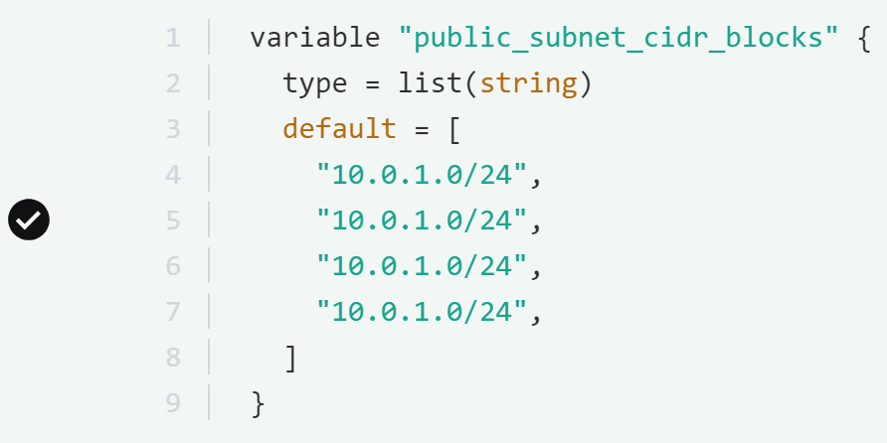
- Which of the following variable declarations is going to result in an error?
  - 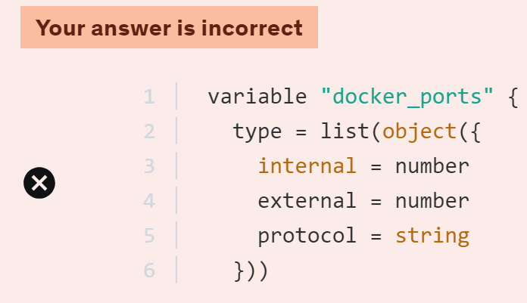
  - 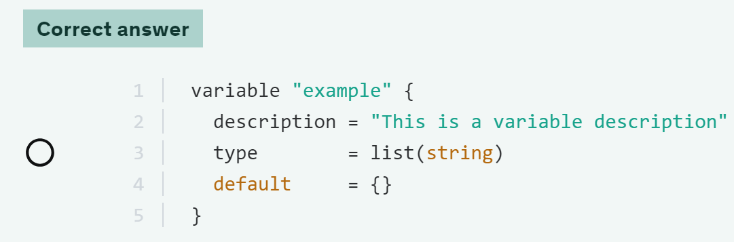
- Understanding how indexes work is essential when working with different variable types and resource blocks that use count or for_each. Therefore, what is the output value of the following code snippet?
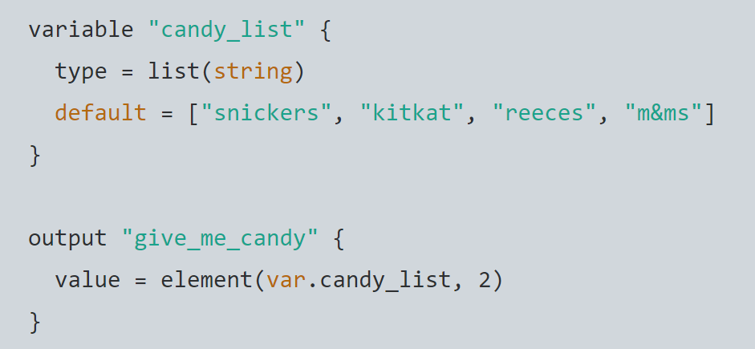
- M&ms
- Reeces
- Slickers
- Kitkat
- Which of the following is NOT a valid variable type in Terraform?
  - Bool
  - String
  - Map
  - Float
- Which of the following is a valid variable name in Terraform?
  - Lifecycle
  - Count
  - Version
  - Invalid
- What Terraform command will launch an interactive console to evaluate and experiment with expressions?
  - Tf get
  - Tf cli
  - Tf console
  - Tf cmdline
- True or False? When using the Terraform provider for Vault, the tight integration between these HashiCorp tools provides the ability to mask secrets in the state file.
  - True
  - False
Objective 9- Understand terraform cloud capabilities
- AutoPlants, Inc is a new startup that uses AI and robotics to grow sustainable and organic vegetables for California farmer's markets. The organization can quickly burst into the public cloud during the busy season using Terraform to provision additional resources to process AI computations and images. Since its compute stack is proprietary and critical to the organization, it needs a solution to create and publish Terraform modules that only its engineers and architects can use.

Which feature can provide this functionality?
- Terraform Registry
- HashiCorp Sentinel
- Terraform Cloud Workspaces
- Private Registry
One feature that can provide this functionality is Terraform's Private Registry. This feature allows organizations to create and manage private modules that authorized users within the organization can only access.
- Your organization requires that no security group in your public cloud environment includes "0.0.0.0/0" as a source of network traffic. How can you proactively enforce this control and prevent Terraform configurations from being executed if they contain this specific string?
  - Create a Sentinel or OPA policy that checks for the string and denies the Terraform apply if the string exists
  - Configure the user's TFC organization permissions to not allow any variables or Terraform configuration that contain this string
  - Perform a terraform validate on the local workstation before committing the code to the code repository linked to TFC workspace
  - Configure a rule in your public cloud provider to scan for security groups and alert you if a security group contains the string
To prevent a Terraform configuration from being executed if it contains a specific string, you can use Sentinel or Open Policy Agent (OPA) to enforce policy checks. Both tools allow you to define custom policies to evaluate and control Terraform configurations before they are applied.
- What is the primary function of Terraform Cloud agents?
  - monitor and troubleshoot Terraform deployments
  - provide remote access to Terraform workspaces
  - store and manage Terraform state files
  - execute Terraform plans and apply changes to infrastructure
- Both Terraform CLI and Terraform Cloud offer a feature called "workspaces". Which of the following statements are true regarding workspaces? (select three)
  - Each CLI workspace coincides with a different VCS repo
  - CLI workspaces are alternative state files in the same working directory
  - Terraform Cloud maintains the state version and run history for each workspace
  - Terraform Cloud manages infrastructure collections with a workspace whereas CLI manages collections of infrastructure resources with a persistent working directory
  - Run history is logged in a file underneath the working directory of a CLI workspace
- Terraform Cloud provides organizations with many features not available to those running Terraform open-source to deploy infrastructure. Select the ADDITIONAL features that organizations can take advantage of by moving to Terraform Cloud. (select three)
  - Terraform registry
  - private registry
  - VCS connection
  - remote runs
  - providers
- Which feature of Terraform Cloud can be used to enforce fine-grained policies to enforce standardization and cost controls before resources are provisioned with Terraform?
  - sentinel
  - remote runs
  - workspaces
  - private registry
- When using Terraform Cloud, what is the easiest way to ensure the security and integrity of modules when used by multiple teams across different projects?
  - Create a list of approved modules and send them to your team to ensure they don't use modules that aren't approved by the team
  - apply TFC organization permissions to all workspaces that allow them to only use certain modules
  - Use the TFC Private Registry to ensure only approved modules are consumed by your organization
  - use only modules that are published to the Terraform public registry
- After many years of using Terraform Community (Free), you decide to migrate to Terraform Cloud. After the initial configuration, you create a workspace and migrate your existing state and configuration. What Terraform version would the new workspace be configured to use after the migration?
  - the most recent version of Terraform available
The new workspace will not automatically be configured to use the most recent version of Terraform available. It will retain the version used during the migration process to prevent any compatibility issues.
  - the latest major release of Terraform
The new workspace will not be configured to use the latest major release of Terraform automatically. It will stick to the version used during the migration to maintain stability and avoid any unexpected changes.
  - whatever version is defined in the terraform block
The new workspace will not be configured to use whatever version is defined in the `terraform` block of the configuration. It will continue to use the version that was used during the migration process to ensure a smooth transition and consistent behavior.
  - the same Terraform version that was used to perform the migration
The new workspace in Terraform Cloud will be configured to use the same Terraform version that was used to perform the migration. This ensures compatibility and consistency with the existing state and configuration.
- Why might users want to utilize Sentinel or OPA with Terraform Cloud in their infrastructure workflow? (select four)
  - Sentinel and OPA enable automated policy checks to enforce compliance standards before applying changes to production environments
  - To provide real-time feedback on potential security risks in Terraform configurations during the development process
  - Sentinel and OPA can enhance security by preventing unauthorized changes to your managed infrastructure
  - To allow users to bypass version control and directly apply changes to production
  - Organizations can enforce resource naming conventions or approved machine images for improved consistency and clarity
- What feature of Terraform Cloud allows you to publish and maintain a set of custom modules that can only be used within your organization?
  - Remote urns
  - custom VCS integration
  - terraform registry
  - private registry
- You are using a Terraform Cloud workspace linked to a GitHub repo to manage production workloads in your environment. After approving a merge request, what default action can you expect to be triggered on the workspace?
  - The workspace will run a speculative plan and automatically apply the changes without any required interaction from the user
  - The workspace will trigger a set of tests, such as terratest and terraform validate, to ensure the code is valid and can be successfully executed by the specific version of Terraform configured for the workspace.
  - Terraform Cloud will automatically execute a terraform destroy operation on your production workloads, and apply the new committed code stored in the GitHub repo
  - A speculative plan will be run to show the potential changes to the managed environment and validate the changes against any applicable Sentinel policies
When you merge a pull request or push changes to the main branch (or any branch you have configured as the trigger for the workspace), Terraform Cloud typically triggers a plan operation. During this plan phase, Terraform examines the proposed changes to your infrastructure and displays a list of actions it would take if applied. It's a way to preview the changes before actually making them.
- Terraform Cloud is more powerful when you integrate it with your version control system (VCS) provider. Select all the supported VCS providers from the answers below. (select four)
  - CVS
  - Github
  - Github enterprise
  - ADO
  - Gitlab

